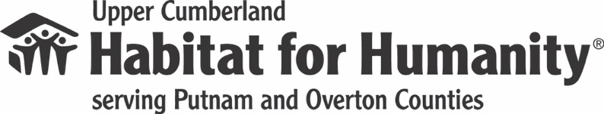

VOLUNTEER OPPORTUNITIES

COMMITTEES
HFH Ambassadors (standing)
The HFH Ambassadors will serve as a development team for our efforts in OC with a focus on building relationships within the community through participation in outreach activities and personal visits (individuals, businesses, etc). Financial support and donated materials will be critical to the sustainability of the ministry. An annual development action plan will be discussed each spring and approved for the coming fiscal year. This plan will be a guide for staff and cmte to follow to build a base of support. Staff support – Trent/Melissa
Church Relations Council (standing)
Identify contacts in various churches and maintain an active church contact list. Members will work to build awareness of the ministry in the church community as well as educate the membership on the possibilities of how working with HFH can impact the members of the church. Long term relationships with churches is the ultimate goal for this committee. Staff support - Trent
Selection Committee (standing, but only meet as needed)
This committee will help publicize the application window. Applications are processed by staff and reviewed by this committee. Training will be provided by staff and the Selection cmte members from Putnam County. The cmte makes the recommendation to UCHFH Board for final approval. This committee will meet based on the need of applications. Staff support – Lanette
New Beginning Lunch Committee (seasonal)
Work together to hold a successful fundraising lunch in the spring. This committee will determine location, menu, décor, etc. in addition, they will train the Table Captains on their role in a successful event. This committee will be active in the months of Dec-Apr annually. Staff support – Trent/Melissa
Rock the Block (seasonal)
This committee will help plan any future Rock the Block (neighborhood cleanup) events. Action items will include recruiting volunteer groups, securing sponsors, and selecting the neighborhood with a work plan. Staff support – Trent

OTHER OPPORTUNITIES
Neighbor to Neighbor PAL (Partner Advocate Liaison)
These positions will work with a Senior that is seeking repair work for his/her home. This volunteer will serve on an assessment team, which goes to the home to verify the repairs that may need to be done. In addition, one helps the Senior to understand the paperwork involved with the project and serves as a primary contact until the repair work is completed.

Neighbor to Neighbor Repair Volunteer
N2N jobs are typically a one or two day repair job. These volunteers work with HFH staff and a crew leader in completing the repairs successfully and on-time. Members of the N2N teams, are asked to commit to 4 or 5 projects within a year.

New Construction Volunteer
When HFH begins building homes in Overton County, volunteers will be needed for weekday construction and Saturday construction. No skills required, as the HFH jobsite is a great place to learn new skills. Skilled volunteers are needed to serve as “crew leaders” on the jobsite.
Rev. February 2019

